6.0 The client and interviews:

The main focus of the exercise was to conduct interviews to gain as much information from clients who wanted a game to be made.

6.1 Interview:

During the interview, information was collected by suggesting ideas to the clients, but wording them as questions.This was effective, as it gave the clients an incentive to correct the proposals and describe how the game should have been designed, such as how the game should function as well as other details like the gameplay to be subject relative.

Another method of eliciting knowledge off the clients was to simply ask yes or no questions. Again this was rather effective when gathering information that wasn’t technical about the game. Details like the purpose of the game as well as the budget available for the project.

6.2 Pitch:

Once the interview had ended, a plan for the game was made and then presented to the clients. After the pitch was done, the commissioning team were pleased with the overall design, which led to them accepting the proposed game as well as the funding to create it for them.

However when explaining how the mechanics were going to work in the game, the clients were not given a clear explanation. This prompted them to ask for a clearer description. Apart from that, no feedback was given by the commissioning team in regards to the project itself.

6.3 Production:

During production, there was difficulty in putting the idea of creating mini games for different subjects for the game. During the interview, one of the information collected was to include mini games that were different for every subject. While there was an example extracted during the meeting, it was a general idea and nothing concrete towards what they desired. So when it came to actually creating examples for the presentation, there were some challenges in brainstorming what could be accepted by the clients.

In order to get around this, only one example was used in the presentation along with how the player will move around the game.

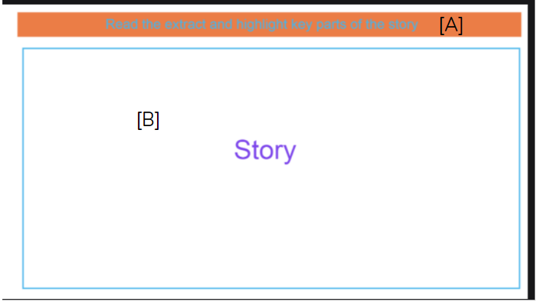

Figure 1. Game Screen. The example game screen aimed towards english literature. [A] would be where the task would have been presented, while [B] was where the player could interact with the screen to complete the task.

6.4 Improvements:

For the interview, it is important that as much information is extracted from the clients. However during the meeting that was conducted with the commissioning team, there were some details that were not gathered. An example would be the fact that there was little to no discussion on play testing which is crucial to game development. Without it then the finished product could potentially deter the players from playing the game if they find it not to their taste.

Another thing that could have been improved was the communication between the team during production, with only the delegation of roles being the only time there was a discussion during the process of planning the game.

6.5 Members:

Sean Colbourne

Sienna Jenkins

Giancarlo Trinidad